**Playstudios BI SQL Assessment**

1. From Table A, sum the number of spins on ‘ios’ for the month of May:

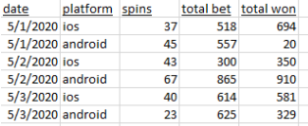

SELECT SUM(spins) AS Total_iOS_Spins

FROM A

WHERE EXTRACT(MONTH FROM date) = 5

AND platform = 'ios';

1. From Table A, show the percentage of total bet in May that occurred on May 2nd:



WITH

total_may_second AS(

SELECT SUM("total bet") AS sum_may_second

FROM A

WHERE date = '2020-05-02'),

total_may AS (

SELECT SUM("total bet") AS sum_may

FROM A

WHERE EXTRACT(MONTH FROM date) = 5)

SELECT ROUND(CAST(total_may_second.sum_may_second AS DEC(12,2)) / CAST(total_may.sum_may AS DEC(12,2)) * 100, 2) AS "% total bet in May second"

FROM total_may_second, total_may;

1. From Table B, use an aggregate function to return the first date per Player ID:

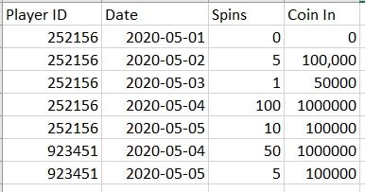

SELECT "Player ID", MIN(Date) AS "First Date"

FROM B

GROUP BY "Player ID";

1. From Table B, use a non-aggregate function to return the first date per Player ID:



SELECT DISTINCT(sub."First Date"), sub."Player ID"

FROM(

SELECT "Player ID",

FIRST_VALUE(Date) OVER(PARTITION BY "Player ID") AS "First Date"

FROM B

GROUP BY "Player ID", Date) AS sub

ORDER BY sub."First Date";

1. Use tables B and C to return Player ID, Date, Spins, Coin In, and Revenue aggregated to Player ID and Date:

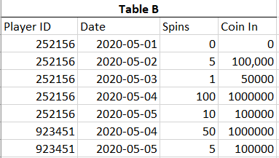

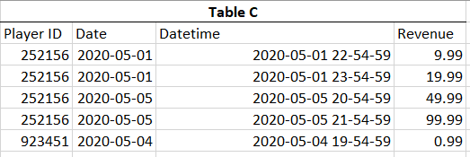

SELECT c."Player ID", c.Date, b.Spins, b."Coin In", c.revenue

FROM C AS c

LEFT JOIN B AS b

ON c."Player ID" = b."Player ID"

AND c.Date = b.Date

GROUP BY c."Player ID", c.Date, b.Spins, b."Coin In", c.revenue;

1. Use tables B, C, and D to return Player ID, Date, Spins, Coin In, Revenue, and Country aggregated to Player ID, Date, and Country:





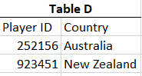

SELECT c."Player ID", c.Date, b.Spins, b."Coin In", c.revenue, d.country

FROM C AS c

LEFT JOIN B AS b

ON c."Player ID" = b."Player ID"

AND c.Date = b.Date

LEFT JOIN D AS d

ON c."Player ID" = d."Player ID"

GROUP BY c."Player ID", c.Date, b.Spins, b."Coin In", c.revenue, d.country;